

**National College of Ireland**

**Project Cover Submission Sheet – 2020/2021**

**Student Name:** Rory Cleary

**Student ID:** x19139306

**Programme:** Higher Diploma in Science In Computing (Software Development)

**Year:** 2019/2021

**Module:** Project

**Lecturer:** Liam McCabe

**Submission Due**

**Date:** 28/08/2021

**Project Title:** MovieHats

**Word Count:** 4732

I hereby certify that the information contained in this (my submission) is information pertaining to research I conducted for this project. All information other than my own contribution will be fully referenced and listed in the relevant bibliography section at the rear of the project.

ALL Internet material must be referenced in the references section. Students are encouraged to use the Harvard Referencing Standard supplied by the Library. To use other author's written or electronic work is illegal (plagiarism) and may result in disciplinary action. Students may be required to undergo a viva (oral examination) if there is suspicion about the validity of their submitted work.

|  |  |
| --- | --- |
| **Signature:** | C:\Users\administrator\Pictures\signature.jpg |
| **Date:** | 28/08/21 |

National College of Ireland

Higher Diploma in Science in Computing (Software Development)

2019/2021

Rory Cleary

X19139306

X19139306@student.ncirl.ie

MovieHats

Technical Report



**Table of Contents**

[Executive Summary 4](#_Toc351559315)

[1 Introduction 4](#_Toc351559316)

[1.1 Background 5](#_Toc351559317)

[1.2 Aims 5](#_Toc351559318)

[1.3 Technologies 5](#_Toc351559319)

[2 System 7](#_Toc351559321)

[2.1 Requirements 7](#_Toc351559322)

[2.1.1 Functional requirements 7](#_Toc351559323)

[2.1.2 Data/User requirements 11](#_Toc351559324)

[2.2 Design and Architecture 12](#_Toc351559328)

[2.3 Implementation 19](#_Toc351559329)

2.3.1 Most Popular ……………………………………………………………… 19

2.3.2 link\_to Image ……...……………………………………………………... 20

2.3.3 Search Bar.……………………………………………………………….. 21

2.3.4 Automatic Time Copyright Notification………………………………… 22

2.3.5 Social Media Links……………………………………………………….. 24

2.3.6 Browse Button in Navbar………………………………………………… 24

2.3.7 Register Button in Navbar……………………………………………….. 28

2.3.8 Cart Icon in Navbar…………………………………………………......... 30

[2.4 Testing 31](#_Toc351559330)

2.4.1 Changing User Password Through the Terminal………………………...33

[2.5 Graphical User Interface (GUI) Layout 40](#_Toc351559331)

2.5.1 Home Page…………………………………………………....................... 39

2.5.2 Login Page………………………………………….................................. 43

2.5.3 Cart Page………………………………………….................................... 44

[3 Project Management 47](#_Toc351559334)

[4 Conclusions **Error! Bookmark not defined.**](#_Toc351559336)

[5 References 50](#_Toc351559337)

# Executive Summary

It is important that in this technological age that every product available for purchase or just for ones’ perusal, can be viewed in the online marketplace. With the invention of mobile devices, we now have the option of utilising the functions of a high powered computer, stored in our pockets and bags.

During my research for this project, I have come across many applications which offer the functionality of well designed database but are seriously lacking when it comes to the front end functionality. My idea for this project is to marry both the backend and frontend and to develop an application that is dynamic on both ends.

I believe it shoud be a requirement to develop an aesthetically appealiing GUI so that user is looking forward to the experience and is left feeling fulfilled long after they close their browser.

The technical aspects will cover a user interface that offers links to all pages, a search bar area that takes the user straight to the product they wish to view, item descriptions that will include functional buttons that offer the ability to add to cart and continue shopping, and images and colours that make the pages pop whilst the user is browsing through the application. There will be links coded into the footer which will, in due course, offer the functionality of linking to social media accounts, but unfortunately at the moment no such accounts exist. Going forward these links will become active.

The database will include tables for admins and users. This ensures the security of the application and maintains separate authentication protocols for each designated user. A register and login function, along with the ability to set and change passwords, will ensure that the user can access the shopping cart to complete their desired purchases. The payment function will link with PayPal so that users can log into their PayPal accounts and issue a secure payment.

# Introduction

The movieHats application will offer users and collectors of movie memorbilia, the oppurtunity to view and purchase items, in particular hats, that have been made famous by various major Hollywood films. It will create an online marketplace that each user will look forward to interacting with. A dynamic GUI will take the user on an experience they won’t forget. Obviously going forward more items will be added to the store and it is envisaged a chat experience will be included also.

## Background

The main reasons that this application will be deveolped will be to offer items that can be proven to be authentic and original. This is not always the case in the online marketplace but it will be a requirement for this application. A Proof of purchase and purchase/selling history will be a necessary requirement before an item is included in the catalogue.

## Aims

To create a memorable, no hassle online experience that users will look forward to interacting with.

## Technologies

The project will be developed utilising the functions and capabilites of numerous different server-side and client-side programming languages. It will begin by developing a database throught the MySQL workbench and subsequently importing this database into the AWS Cloud9 IDE.

The Cloud9 IDE is a class leading cloud application that will ensure the movieHats application is developed with the most effective and efficient methods available.

Ruby on Rails will be the main development language utilised and it will include functions and dynamic from HTML and CSS. Along with this, the main styling of the application will be developed using W3.CSS. This powerful mobile first library provides a responsive and modern twist for developers to include into their project code Figure 1.

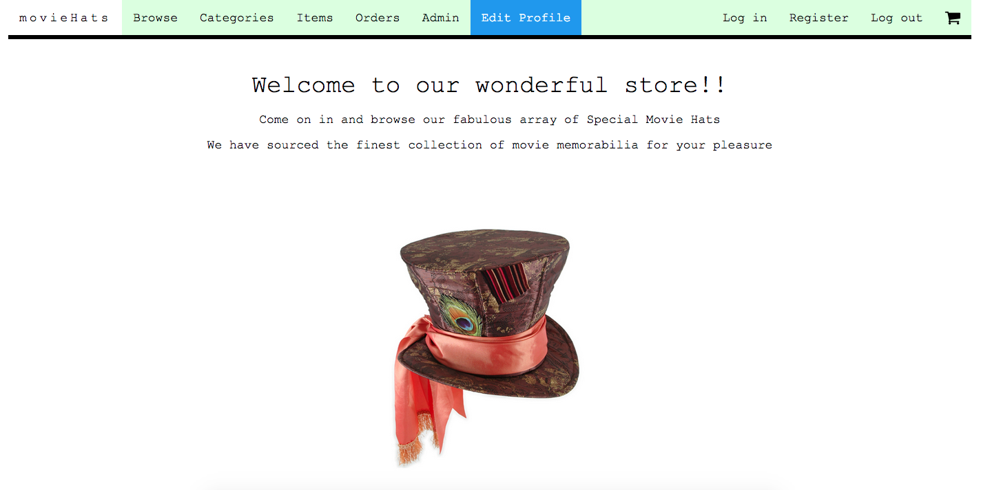

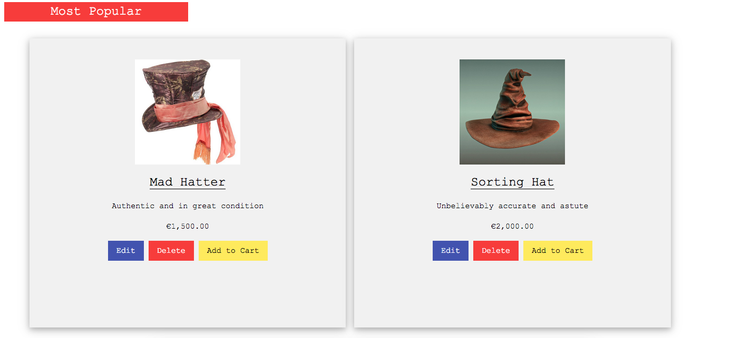

Figure 1

Finally when it comes to a secure payment function if and when the user decides to purchase an item, the application will interact with PayPal so that users can be rest assured that their payment transaction is completely secure.

# System

## Requirements

The requriements of the appplication have not changed since the original conception. It was designed with all the functionality it needed and it was not deemed necessary to change any functions during the development process.

### Functional requirements

The following is a list of the functional requirements of the application. They are separated into Administrators, Registered Users/Non-Registered Users.

**Administrators:**

* Ability to update all aspects of the application
* Create/delete items, Figure 2

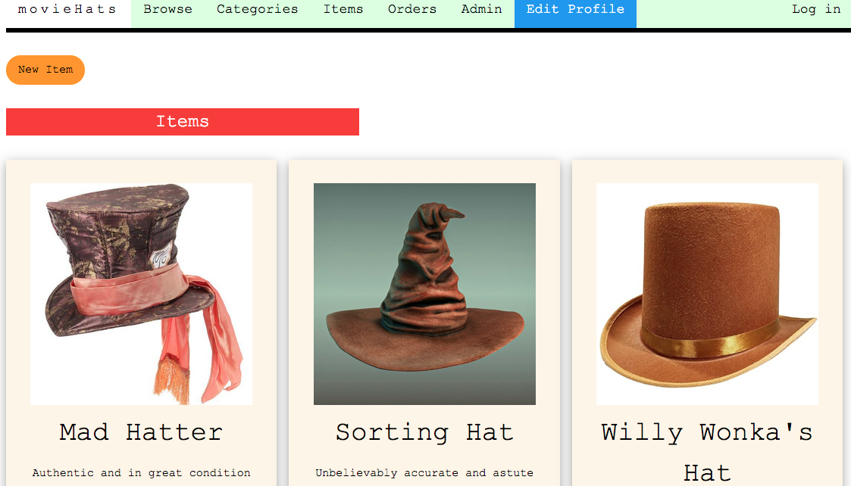

Figure 2

* Access to the orders section, Figure 3

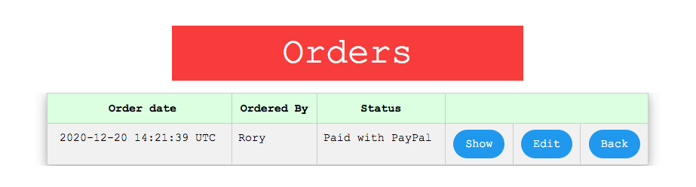

Figure 3

* Add/delete user as an admin, Figure 4

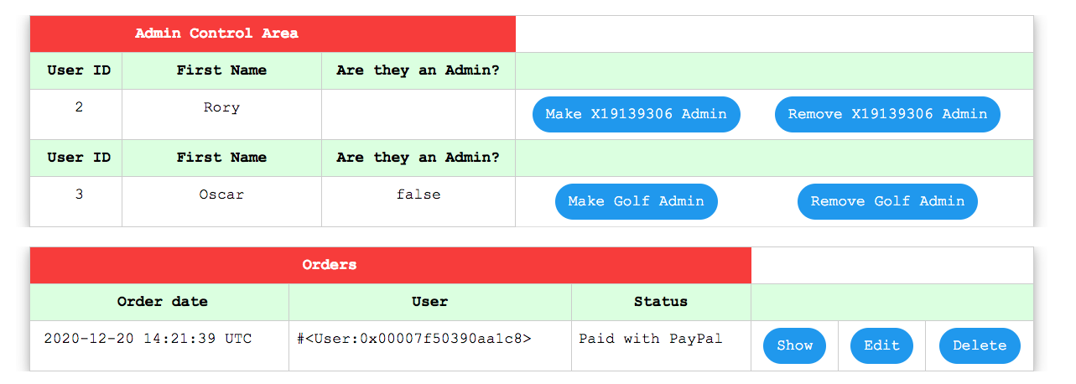

Figure 4

**Registered Users:**

* Log In section, Figure 5

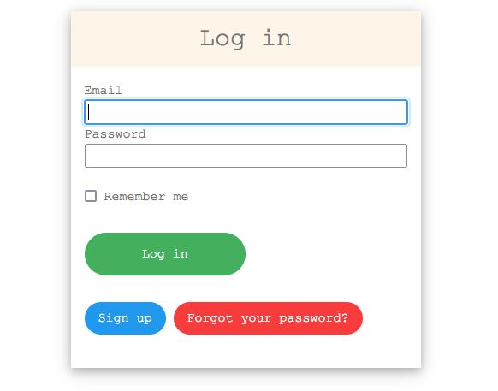

Figure 5

* Log Out button in Navbar area, Figure 6

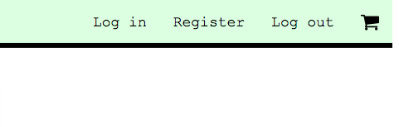

Figure 6

* Delete account
* Access to the shopping cart, Figure 7

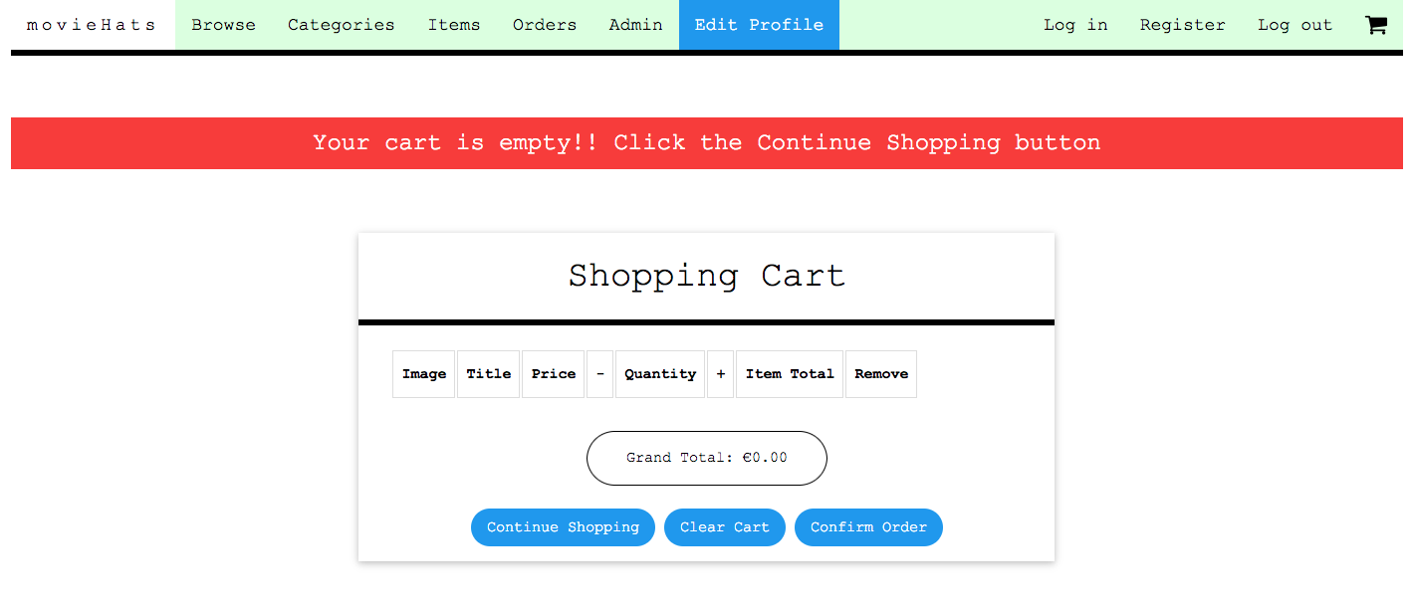

Figure 7

* Purchase items
* Order history
* Order status, Figure 8

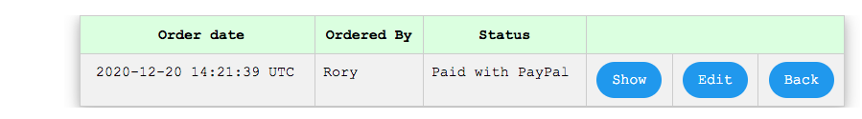

Figure 8

**Non-Registered Users:**

* Browse application
* Browse catalogue

### Data/User requirements

A user who chooses to register for an account has certain data obligations that have to be achieved in order to create an account. Since currently all payments are be re-routed through PayPal, the criteria for data requirements is at the lower end of the scale. All data is securely amassed and saved as part of our application. The devise gem takes care of this by creating a new session when the user logs out.

<%= csrf\_meta\_tags %> is a line of code which controls access to your application from unauthorized users. It acts as a digital signature and only accepts a request from a user who has correctly logged into the app.

The following personal data that is required is Figure 9:

* First name
* Last name
* DOB
* Phone Number
* Email

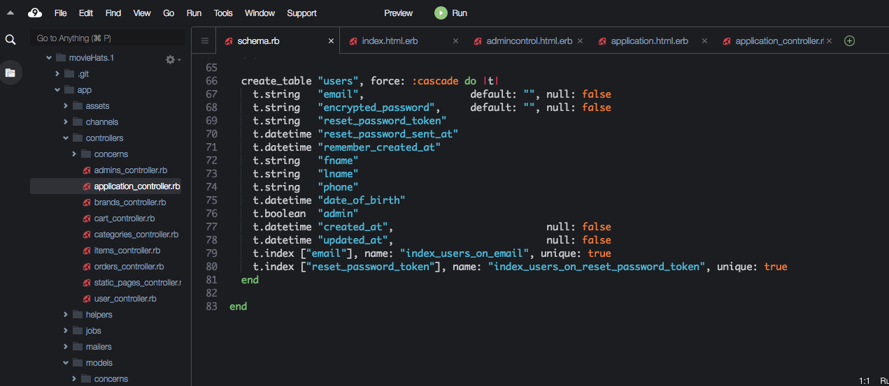

Figure 9

## Design and Architecture

Originally I created the database in MySQL workbench and then imported it into the Cloud9 IDE incorporated in Amazon Web Services. This a class leading app and allows the developer to produce projects without exiting the environment.

The schema includes tables called Admins, Categories, Items, OrderItems, Orders and Users Figures 10a, 10b, 10c, 10d, 10e. Going forward I will increase the database to include tables such as UserPayments, which will allow this application to offer payment services using the users credit or debit card.

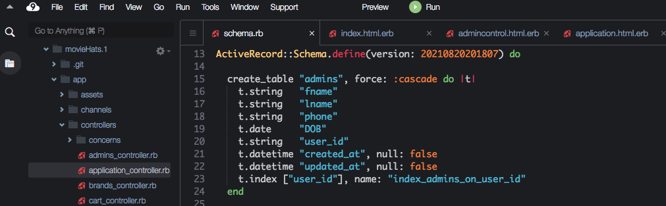

Figure 10a

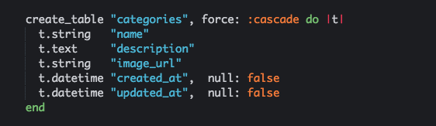

Figure 10b

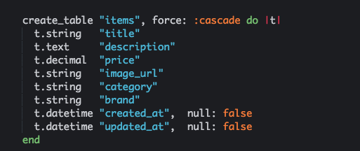

Figure 10c

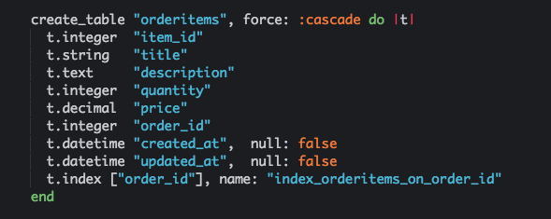

Figure 10d

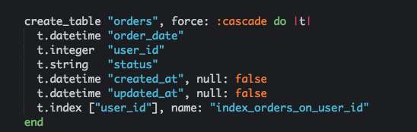

Figure 10e

As the development process continued I created the following design documents which directed me when it cam time for the coding of the app.

The design documents are:

* Use Case Diagram
* Package Diagram
* Class Diagram
* Sequence Diagram

Use Case Diagram, Figure 11

147:Final_Project:MovieHats Use Case Diagram.pdf

Figure 11

Package Diagram, Figure 12

147:Final_Project:MovieHats Package Diagram.pdf

Figure 12

* Class Diagram, Figure

147:Final_Project:MovieHats Class Diagram.pdf

* Sequence Figure 13

147:Final_Project:MovieHats Sequence Diagram.pdf

Figure 13

## Implementation

### Most Popular

The main classes and functions developed into the code begin on the home page with a Most Popular Items section Figure 14.

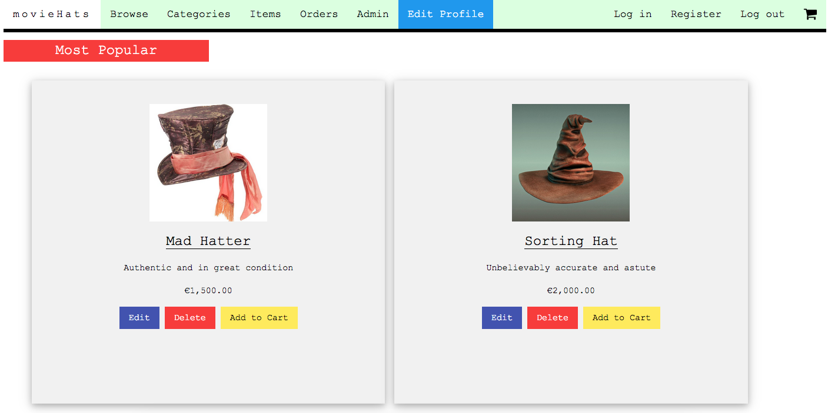

Figure 14

This method is created by addng the following code snippet to the application Figure 16.

*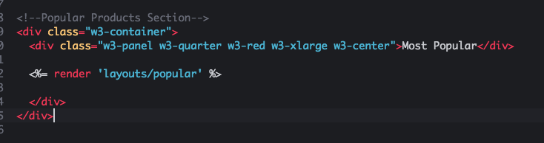*

Figure 16

A \_popular page is created in a layouts folder Figure 17 and it renders the code through the static home page. The Most Popular Items are then rendered and are visible everytime a user visits the homepage.

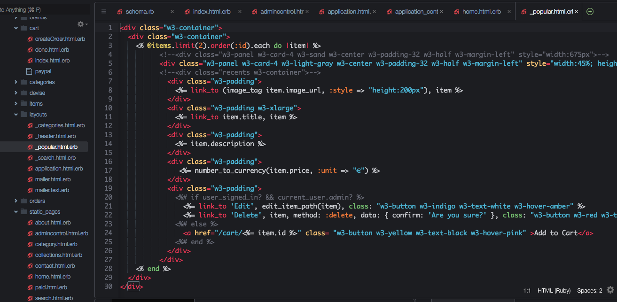

Figure 17

What is happening is actually the magic of the MVC in Ruby on Rails. The Controller is interacting with the View to ensure that the proper piece of code is displayed correctly in the browser. The Controller is managing the request by rendering the \_popular Items page and sending the result back through the View.

This result is what is visible to the user in the browser window Figure 14.

### link\_to Image

The home page also displays an image under the navbar which is an active link that sends the user straight to the collections page. The link\_to method is utilised here for this interaction to take place.

The link\_to is activating the image when the user hovers over it and when the user clicks, the collections is rendered in the browser. This is dynamic web development in action Figure 18.

**

Figure 18

### Search Bar

Another example of dynamic web development is demonstrated in the navbar area with the Search method. The search bar is shown in Figure 19.



Figure 19

This code is rendered in a similar way to the \_popular page. A \_search page is included in the layouts folder Figure 20.

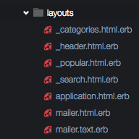

Figure 20

When the user requests this function through the search bar, the controller sends the details into the model and back into the view, where the user can view the desired items in relation to the search request.

The search method is created with code from a jquery library. I researched this for an earlier module and have included it with this project. The research will be linked in the bibliography.

As you will notice with the code in Figure 21, it states thatwhen the user enters a search term into the search box, with has a message of ”Search and Enter”, that they will receive the result in the form of a text request, which will then display all the items in relation to this search request.

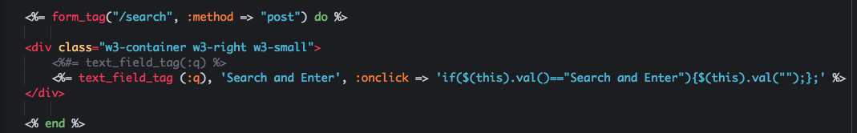

Figure 21

### Automatic Time Copyright Notification

Staying on the hompage but actually coded in the application.html.erb page is a date notification function. This is located in the bottom left of the footer section and the user will notice that the current year is displayed Figure 22.



Figure 22

This method automatically generates the current year and displays it in the desired section that the developer requires. The code for this method is displayed in Figure 23. It is a copyrightnotification that will update every year automatically.



Figure 23

### Social Media Links

Also on the home page in the footer section are icons which will be links to the various social media pages connected to this application. As those social media pages have not yet been created these links are currently inactive.

The code for the icons is as follows in Figure 24.

*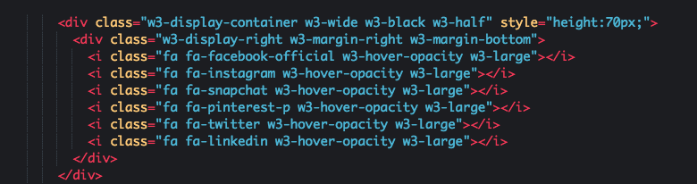*

Figure 24

Below is an image of the icons located at the bottom right of the footer section Figure 25.

**

Figure 25

### Browse button in Navbar

The browse button located in the navbar acts as a link to the collections page Figure 26.

**

Figure 26

The code for the browse button is located in the \_header.html.erb page in the layouts folder Figure 27.

*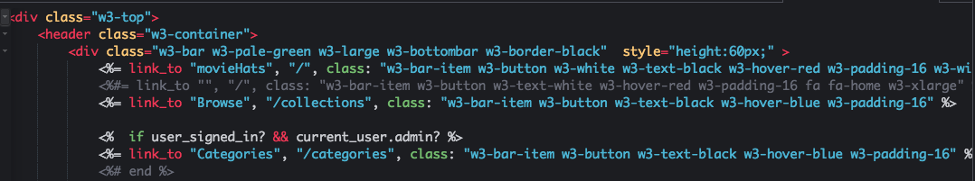*

Figure 27

When the user clicks this button the collections page is rendered. The user can browse through the online catalogue and shop for desired items Figure 28.

*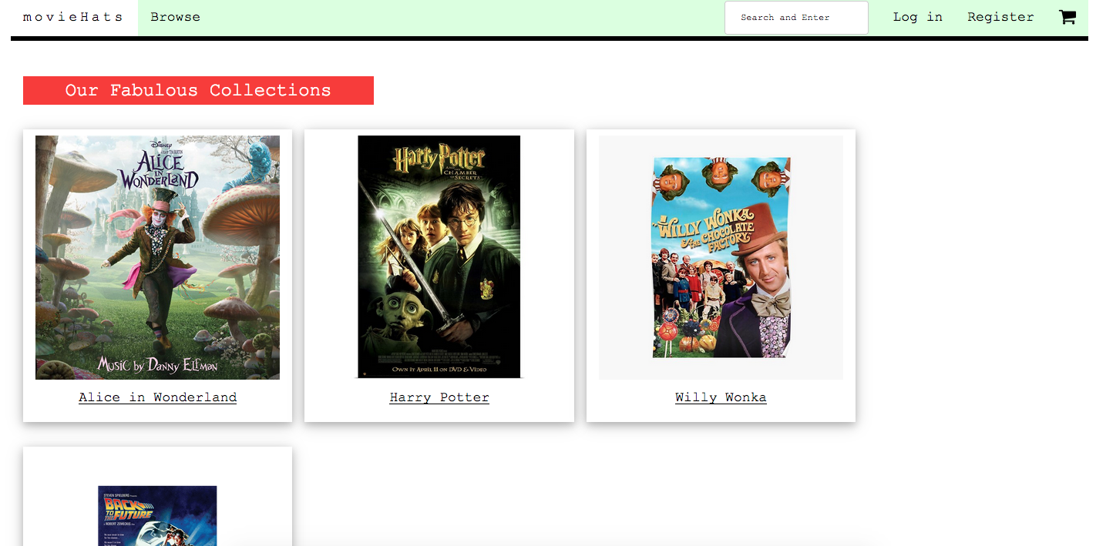*

Figure 28

After the user enters the Collections page, they will met with a series of images which connect to a particular item from that brand. These different categories have been developed through a Category page which stores the items information Figure 29 and subsequently connects with the Categories page Figure 30.

*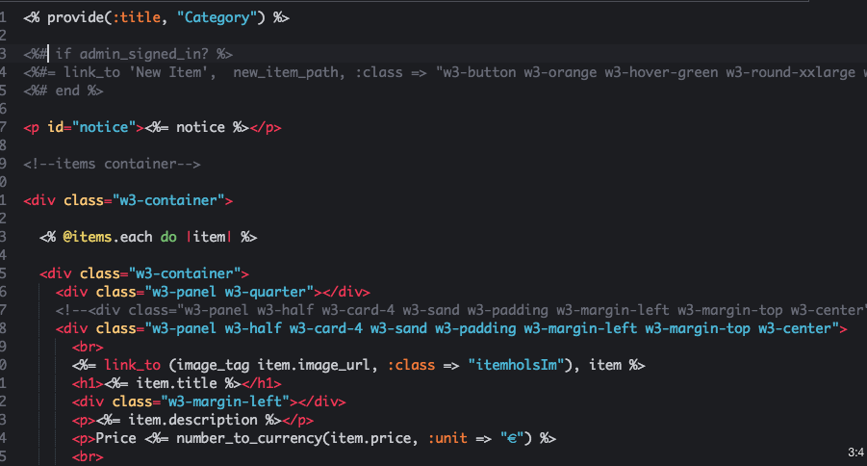*

Figure 29

*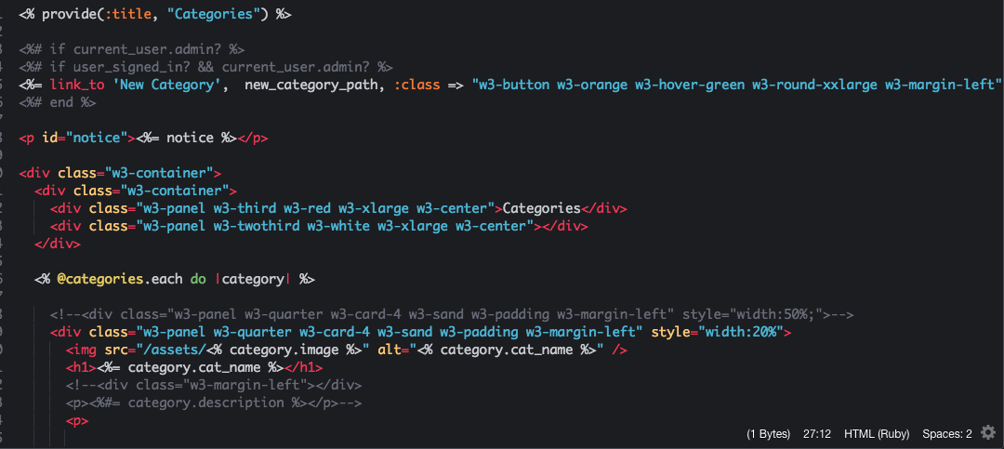*

Figure 30

As mentioned earlier all these interactions are connected through the MVC framework in Ruby on Rails. The view sends a request to the controller whom sends it on to the model and it eventually gets passed back to the view for the user to visualise the final result in their browser.

The final view in the browser of the user is below in Figure 31.

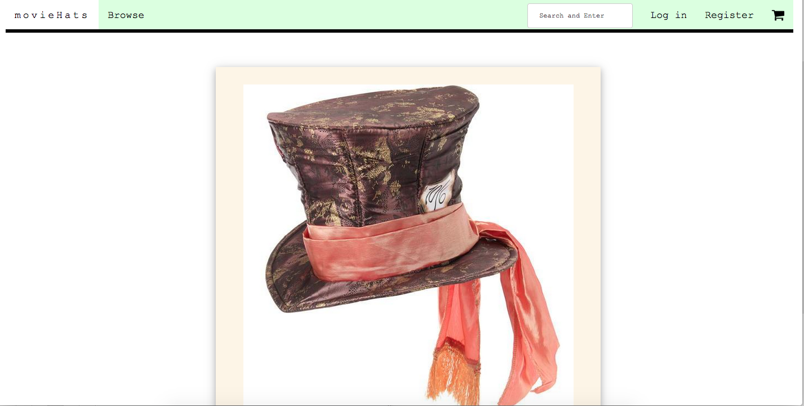

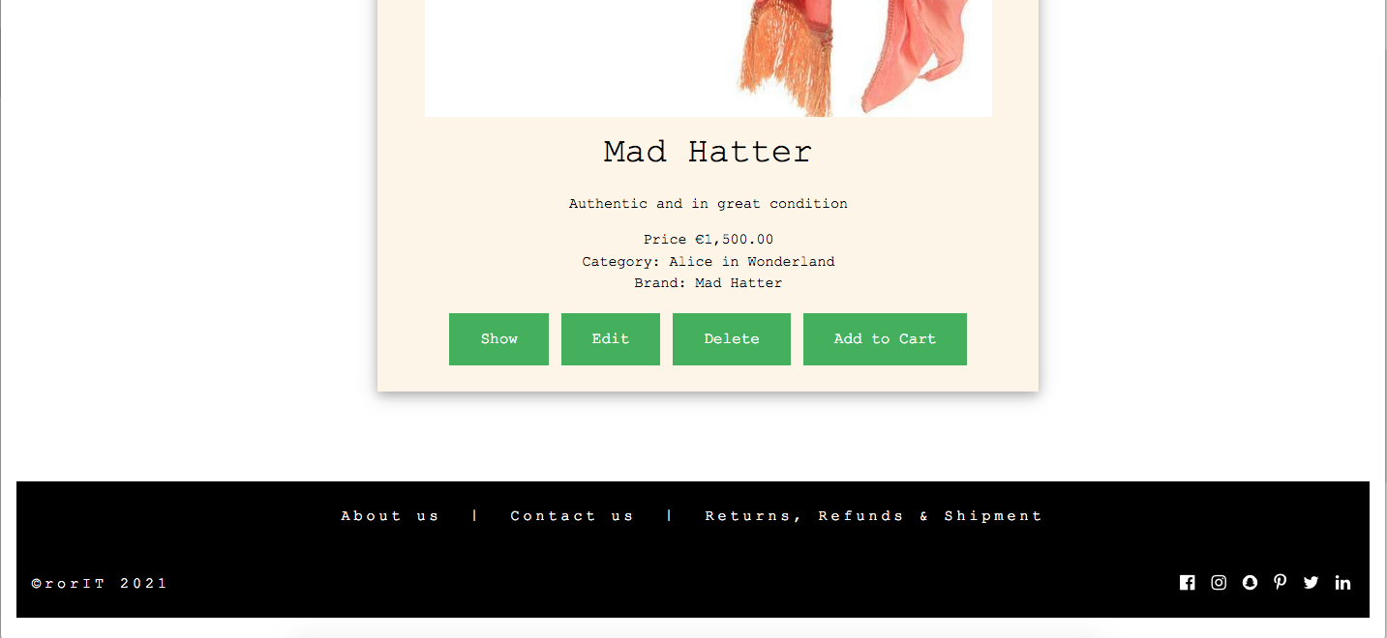

Figure 31

### Register Button in Navbar

The Register button in the navbar, when clicked, will open up a new page that displays a Sign Up box Figure 32.

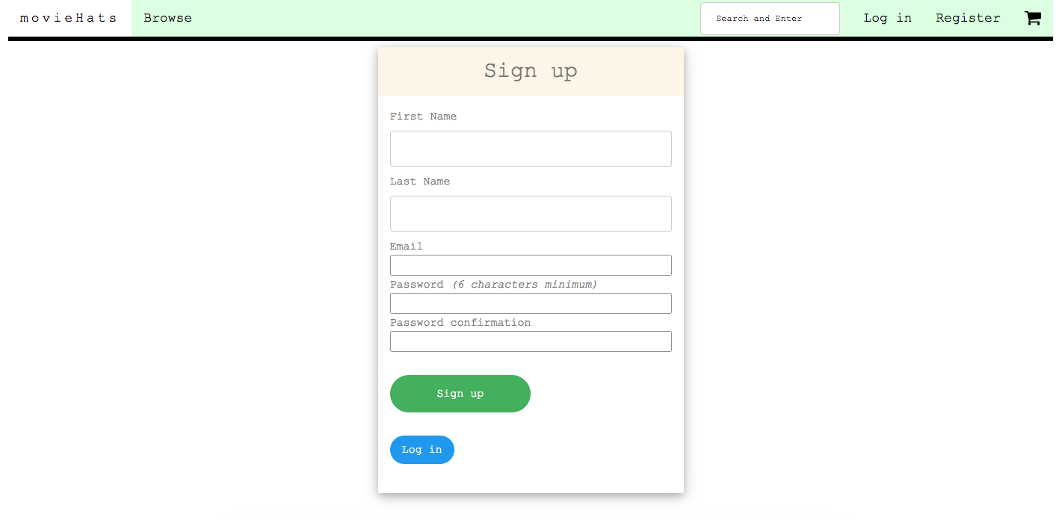

Figure 32

The User will then be required to enter their first name, last name, email and generate a new password with certain parameters attached. This is the requirement for a new registered user. The method for this to develop is displayed in the following code Figure 33.

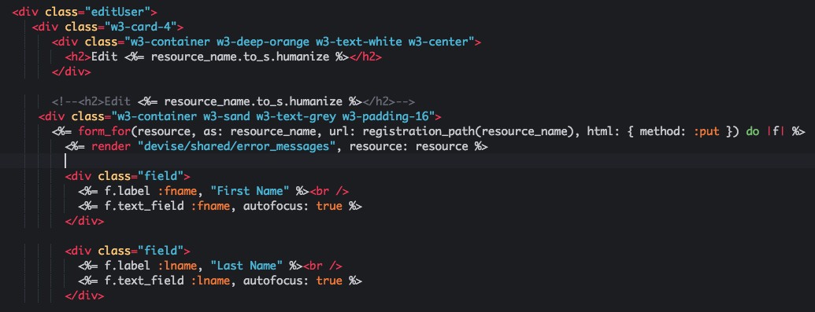

Figure 33

The location of this method is in the users folder in the views section of the app Figure 34.

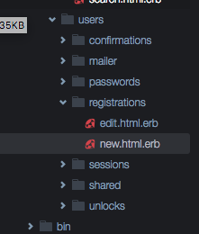

Figure 34

This method is developed as part of the process of creating authentication in your app. The devise gem is installed to begin with and subsequently each separate page and method is created and developed to ensure that the application is secure. Admins and Users will have separate authentication protocols in place Figure 35

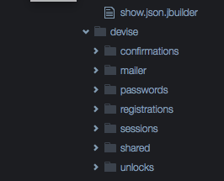

Figure 35

### Cart Icon in Navbar

The Cart Icon in the navbar is linked to the Cart shopping page. When an authenticated user logs in, they are granted permission to access the cart area. Non-registered users have no permission to access the cart. The image in Figure 36 displays an empty cart with the pre-coded message “Your cart is empty!! Click the Continue Shopping button”

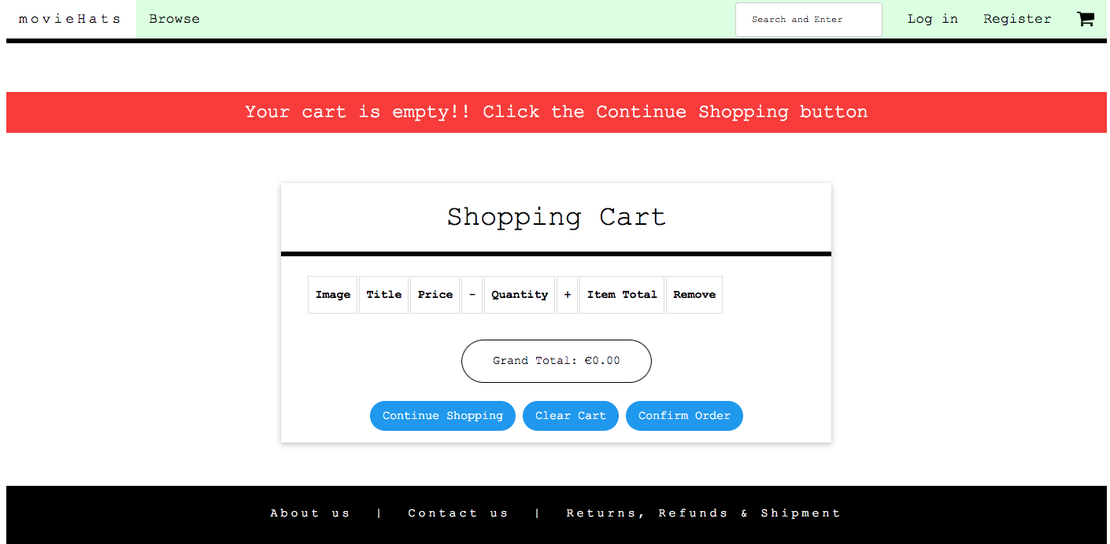

Figure 36

The method used for this is located in the cart folder in the views section of the app Figure 37 and accessed by the MVC with follwing code Figure 38.

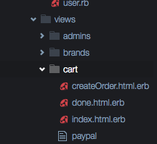

Figure 37

*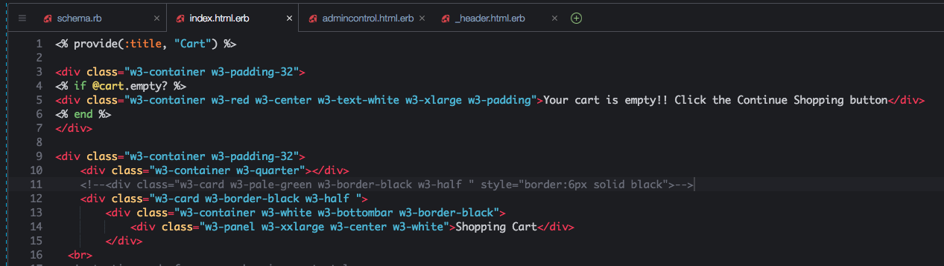*

Figure 38

As the user continues shopping and decides to place an item in their shopping cart the message alert is removed and an item is displayed in their shopping cart Figure 39.

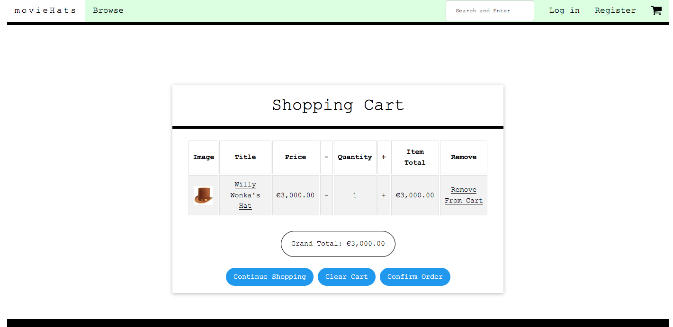

*(Figure 39)*

## Testing

System Testing was conducted after every iteration of the project was developed. This continuous test driven development protocol ensured that the project stayed on track with its’ timeline. It is vitally important to the success of a software development project that testing is implemented regularly.

All sections of the app need testing. Whther it is the CSS, HTML or Ruby on Rails. The databse was tested extensively beforehand in MySQL Workbench and imported when it was functioning correctly.

When testing for the search page I removed the search page from the static pages folder in Figure 40a and Figure 40b

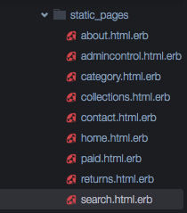

Figure 40a

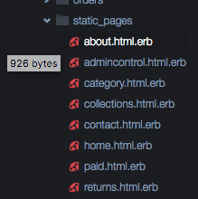

Figure 40b

and immediately when I ran the application I recevied an ActionController error, as shown in Figure 41.

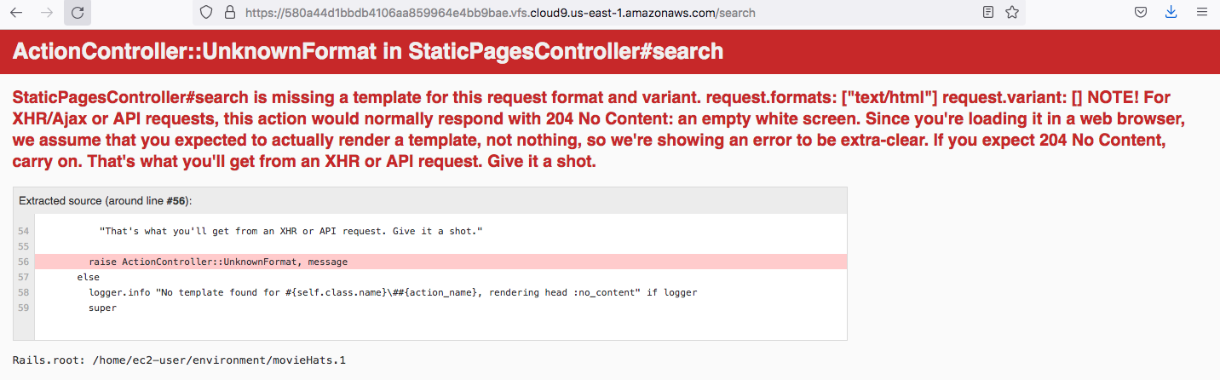

Figure 41

As soon as I reinstated the search page, the test was complete and the application ran correctly once again Figure 42.

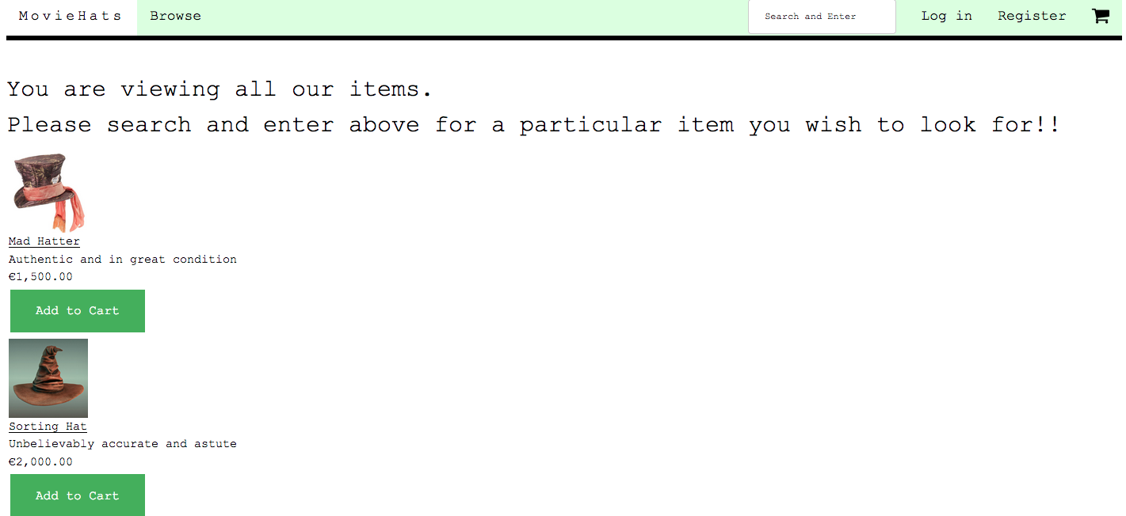

Figure 42

### 2.4.1 Change User password through the Rails Terminal

As previously mentioned I am having a little trouble in changing the password through the email password recovery mechanism. I researched a way around it and can chage it through the rails c terminal. Figure 43 displays the command to begin this process.

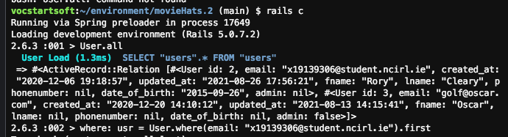

Figure 43

You might notice that I am testing this in a duplicate app, movieHats.2, which I am using for testing purposes as the deadline is due and I do not to cause an issue with the main app. I like this practice as it keeps my main app free from any major issues. I can then update the code in my main app when I feel that the testing is complete.

The whole process required creating a new users controller file named index.html.erb file in the users folder. I completed this with the following commands in Figure 44.

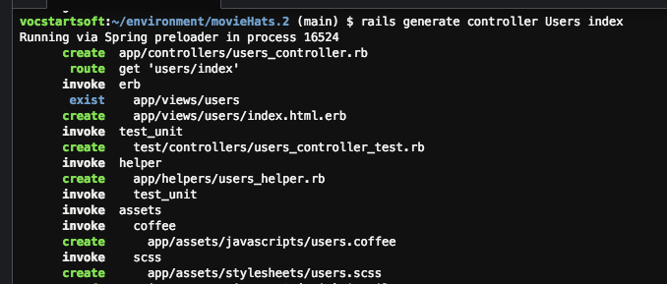

Figure 44.

In the users\_controller.rb file I added the following code to the index in Figure 45.

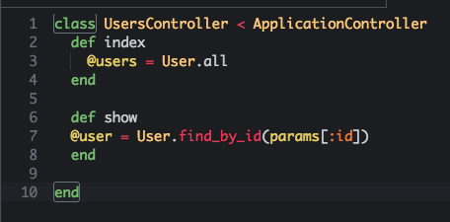

Figure 45

Figure 46 displays the code added to the index.html.erb file to allow for the parameters to be viewed in the browser. But unfortunately I received a NoMethodError as shown in Figure 47.

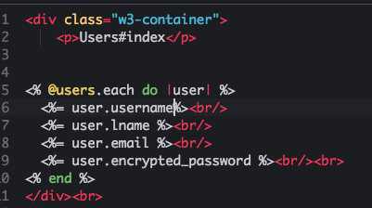

Figure 46

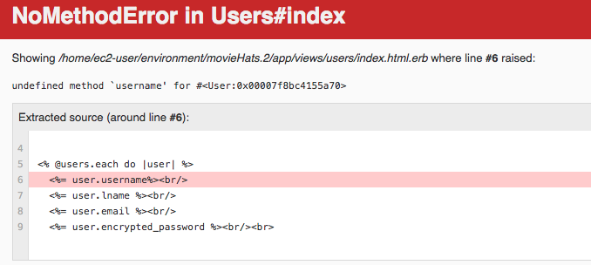

Figure 47

This is why I choose to develop and test in a separate app to the main app. I can safely develop and test, which allows me to update the main app when I have it running correctly.

The issue that I found was that the user.username parameters were not matching the users table. In the users table it has user.fname instead of the user.username. Figure 48 displays this.

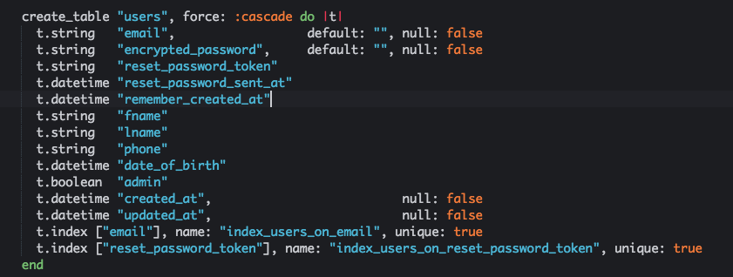

Figure 48

I rectified this issue and renamed the show and index files accordingly.

Next in line was to change the routes file. I inserted the code in Figure 49 into this file so that the application could get the details the developer requires.

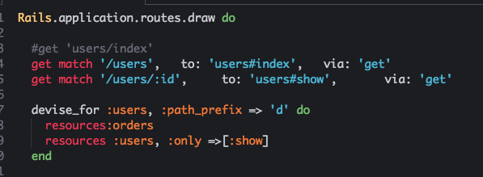

Figure 49.

Unfortunately another error was declared and I was unable to restart the app. Figure 50 displays this error. It was a duplicate entry in the routes file for devise for user.

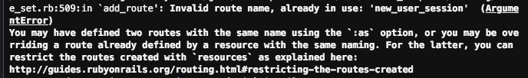

Figure 50

The reason for this error was that the routes already a devise method for users. So it needed to be integrated into the new method. Figure 51 shows the updated code for devise for users.

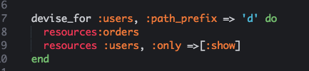

Figure 51

After these errors were rectified I subsequently ran a check in the rails c for the Users connected to the app. Figure 52 displays this check and the results in the terminal while Figure 53 displays the Admins.

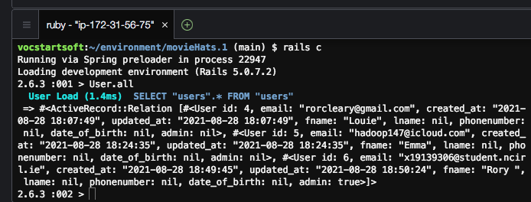

Figure 52

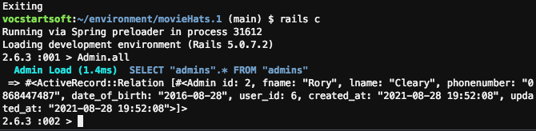

Figure 53

The name, email and hashed password are visible. But as I could not decode this hashed password, I decided to change the password through the terminal.

The procedure for changing the password in the terminal are as follows. I stored the user data in a .first variable and then updated the variable to change the password. Figure 54 displays this procedure.

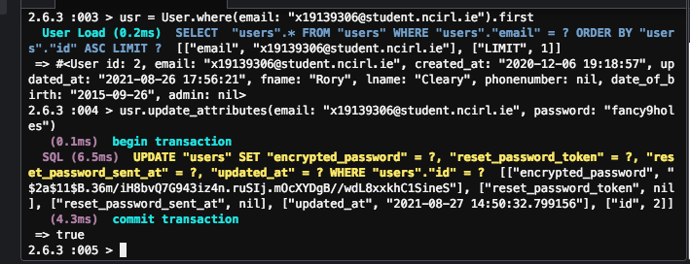

Figure 54

After changing the password in this manner, I was able to gain access to my account in the app.

Just a short note to mention that after further research I realised that I could change the user\_password through the rails terminal without the need to create a new users controller or change the routes file either. This is why it is so important to develop and test and then repeat the same procedure to ensure that you have an application running correctly and without any bugs.

For this reason it was not necessary to update the main app with this code. I couold access the user and admin accounts through the terminal.

## Graphical User Interface (GUI) Layout

### HomePage

The GUI for the movieHats project is designed with maximum user interacton in mind. This begiins on the HomePage where the user has a relaxing colour scheme and easily accessible buttons and links, along the Navbar, to utilise at their pleasure.

The Home Page Figure 55 incorporates an image that is an active link to the Collections Page, where upon the user can access all the items, which are categorised, and decide upon which item they would like to pursue to a purchase.

The Most Popular section is created by linking the categories and items and routing them through the MVC process, where they coded to display on the Home Page under the Navbar and the main image. These items will obviously change as more users visit the app and purchase certain items.

The Search bar is located in the Navbar also, for ease of access and users can search for items through numerous different variables.

The Login and Register links are also located in the Navbar, along with access to the Cart, for registered users.

All buttons change colour when a user hovers over them.

The Navbar is static and stays in place whenever the user scrolls up or down the page. The method used for this function is displayed in Figure 56.

By simply adding a “w3-top” class to the \_header section, the Navbar will remain static. Without doubt this helps with the user experience, as the user can navigate to any other page or link with this function.

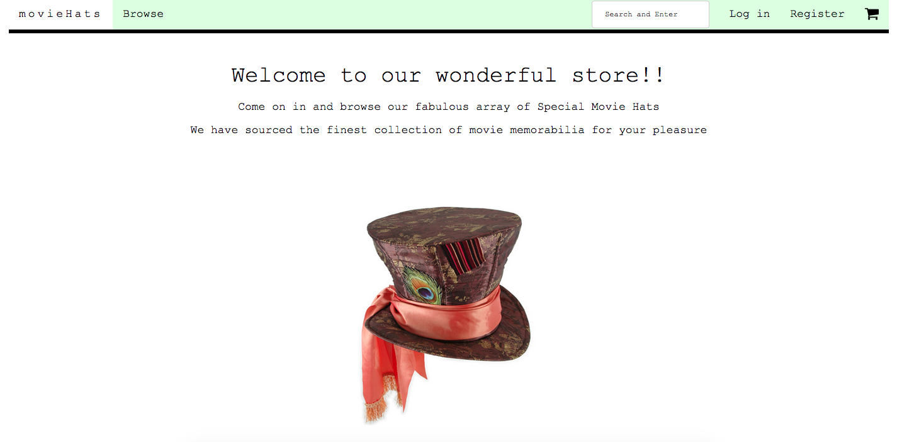

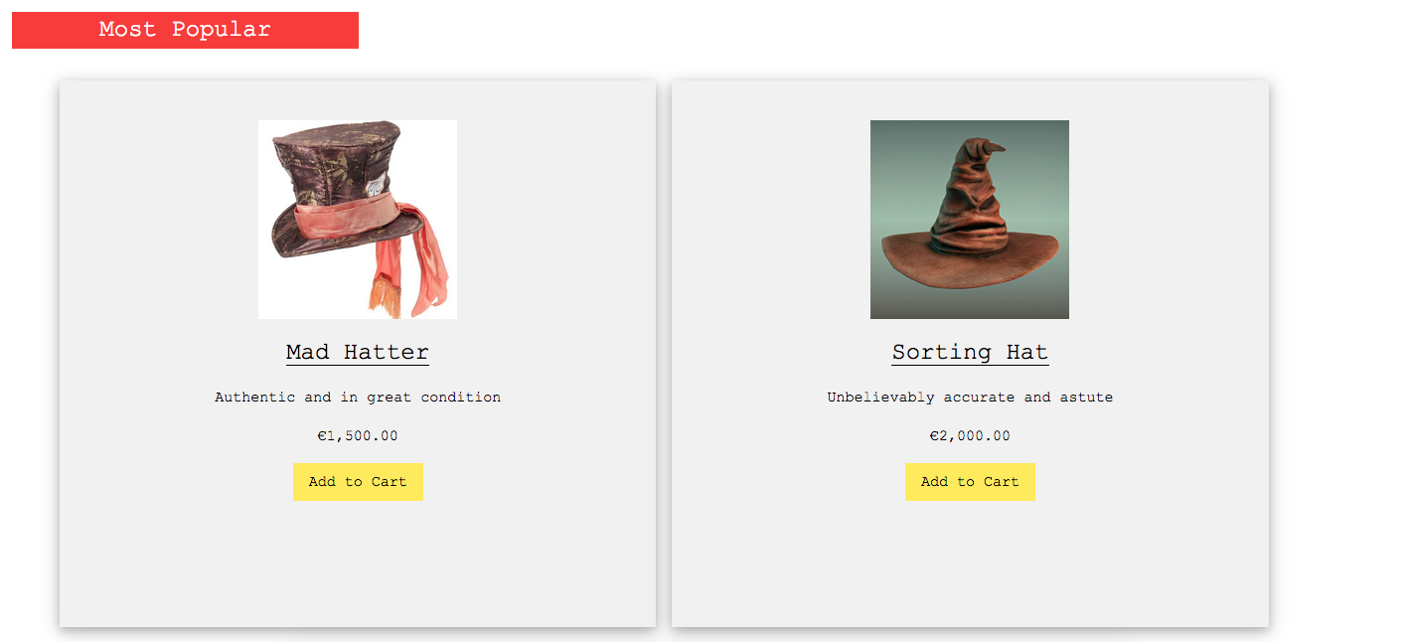

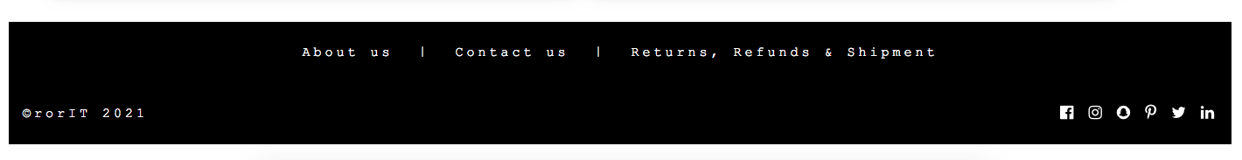

Figure 55

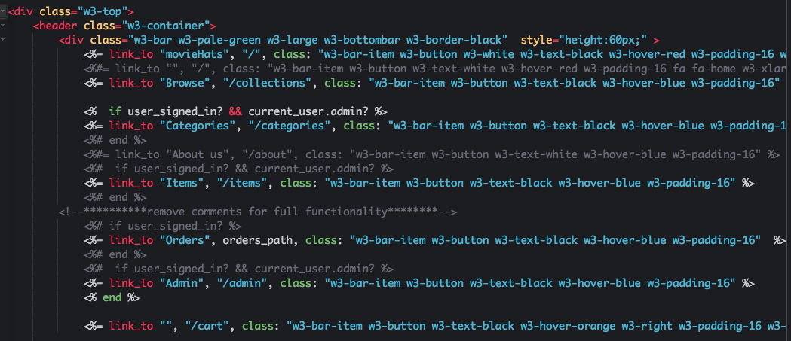

Figure 56

### Login Page

Figure 57 displays the Login page in the browser. The Navbar is still available and the Login box is featured in the centre of the page. It shows a variety of colours, that will endeavour to ensure that the user has clear visual clues as to what is expected. The buttons are multi-coloured so as to differentiate the styling aspects, with the object not to confuse the user.

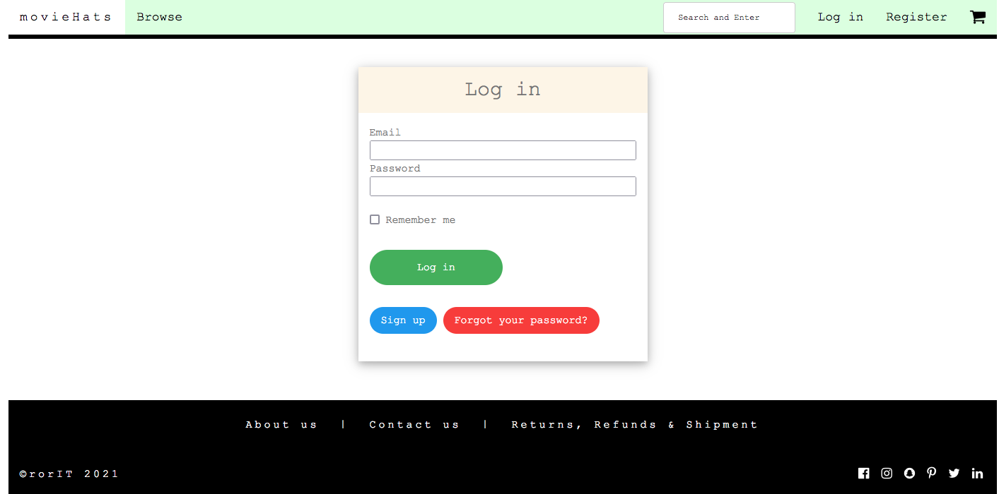

Figure 57

There is also a Remember Me box that the user can click. This will enable the application to store the data of the user which will speed up the login process in subsequent visits, Figure 58.

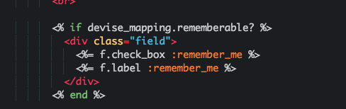

Figure 58

### Cart Page

The Cart Icon in the navbar is linked to the Cart shopping page. When an authenticated user logs in, they are granted permission to access the cart area. Non-registered users have no permission to access the cart. The image in Figure 59 displays an empty cart with the pre-coded message “Your cart is empty!! Click the Continue Shopping button”



Figure 59

The method used for this is located in the cart folder in the views section of the app Figure 60 and accessed by the MVC with follwing code Figure 61.



Figure 60

**

Figure 61

As the user continues shopping and decides to place an item in their shopping cart the message alert is removed and an item is displayed in their shopping cart Figure 62.



Figure 62

### Payment Page

The payment page is connected to PayPal. When a user decides to ‘Buy Now’ they just have to click on the ‘Buy Now’ button on the payments page which reidrects them to PayPal. Figure 63 displays the payment page. The user can check their order number and price of the item and then choose to pay by clicking the ‘Buy Now’ button.

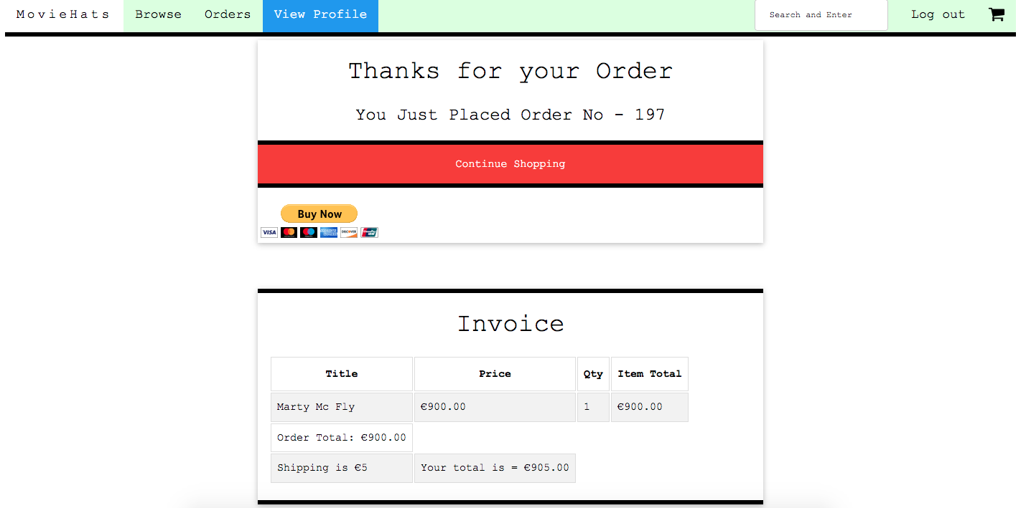

Figure 63

After clicking the ‘Buy Now’ button they are rediredcted through to the PayPal application to complete the transaction as shown in Figure 64a, Figure 64b, as a Guest in Figure 64c. The below images display that when I transfer to the PayPal app that I have to input the total amount manually. This must be an issue with the PayPal sandbox account and would hopefully not happen with the real PayPal account connected to the user. (N.B The PayPal sandbox account is obviosly used just for testing purposes only.)

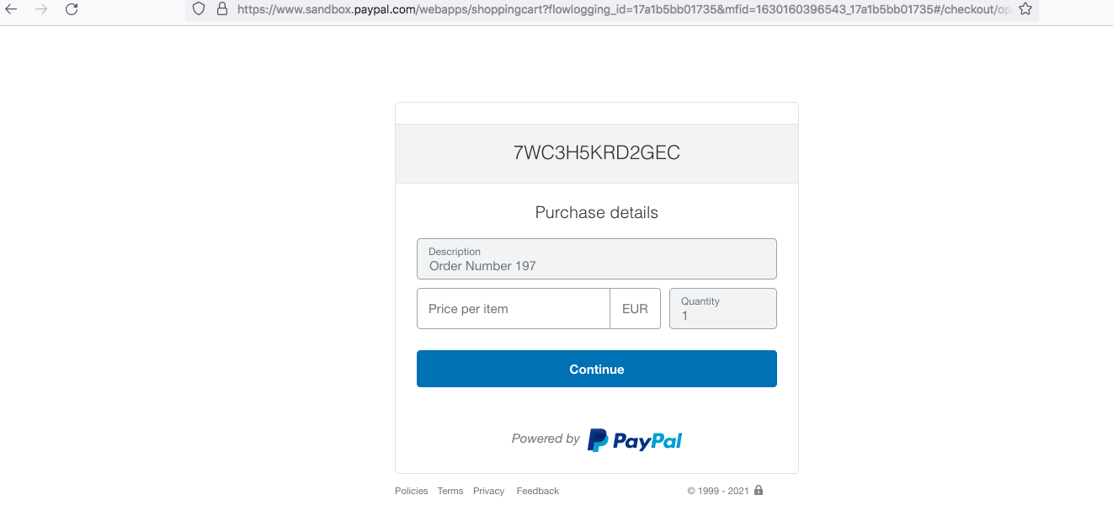

Figure 64a

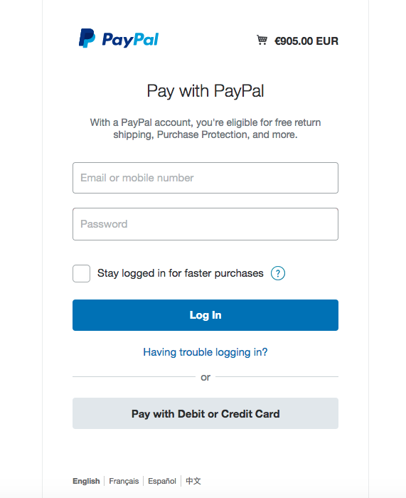

Figure 64b

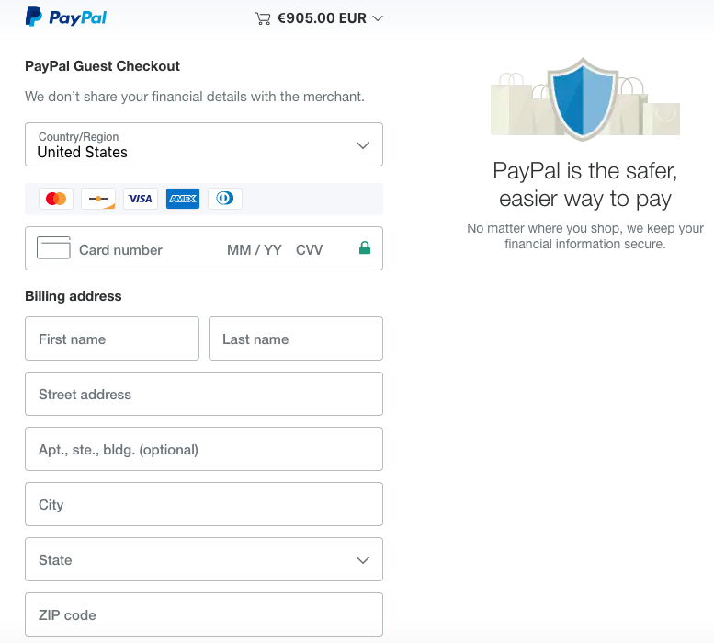

Figure 64c

# Project Management

The project was managed by a Gantt Chart that I produced on the first day of developing. I declared a topic for each stage and strictly adhered to it. If I felt I was vereing off course, I would just view the chart and get the project back on track It was imperative that I created this chart, as without a doubt it helped me immensely. The project was completed and submitted within the scheduked time limit.

Below is an image of the Gantt Chart that I created in Figure 63.

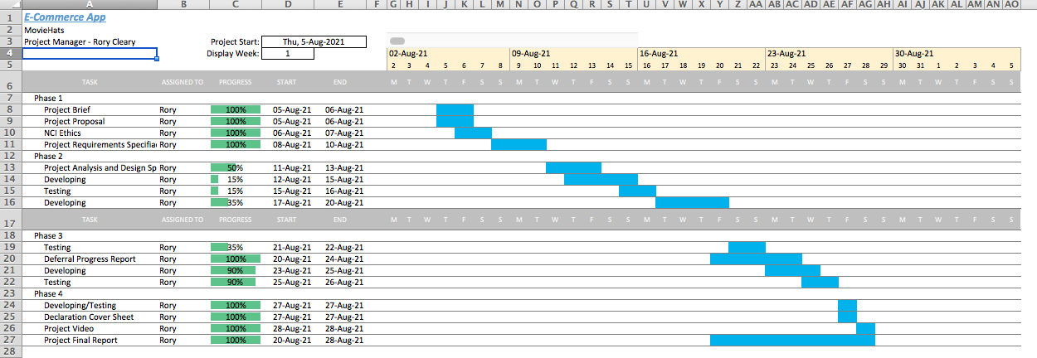

Figure 63

# Conclusions

In conclusion, this project has been developed and researched utilising all the extremely useful information that I received during my time on this course in NCI. I conducted research for all areas of this project but concentrated my efforts especially on the devise gem. I found this area by far the most difficult to get correct, but in the end I am delighted to have produced a project that is of a high commercial standard. I have enjoyed developing it immensely and will endeavour to enhance and imrpove it going forward.

Presently the only remaining issue that I am encountering is in the devise method when a user forgets their password. I am getting an error message which I will research further and with a bit more time, will hopefully rectify this little bug.

I am proud of my efforts on this project, considering that I had to defer it due to a major incident that happened to my family and I in December 2020. Once again I wish to offer my sincere thanks to the NCI for their support during this time. I have no doubts that I will improve this project as time goes by.

As far as I am concerned, NCI have put together a comprehensive and market leading study program in the field of Computer Science. My skillset has undoubtedly improved, as a result. My wishes for the not too distant future are to apply for, and hopefully get accepted onto the Msc. in Cybersecurity program.

The backend of this project is perfect at the moment. If I choose to scale it up into the future, I have the abilites to complete this update without any hassles.

The frontend is where I want it to be also. I like the idea of using colour to enhance the user experience. I feel it is important for the user to have a clear visual message of what is expected of them, when interacting with the application.

With the devise gem installed, the security of the application is as high as it can be. No application can be completely secure from a cyber attack but at least with certain protocols and measures embedded in your code, the application has a level of protection that will undoubtedly improve and secure it.

Unfortunately I didn’t get to set up a Heroku account for this app. Time constraints went against me. My apologies for this.

# References

Heinemeier Hansson, David. (Rails Guides). ‘Active Record Migrations’. <https://guides.rubyonrails.org/active_record_migrations.html> (Accessed 5 August 2021).

Data, Refsnes. (W3Schools 2021). ‘W3.CSS Tutorial, A Quality Alternative To Bootstrap’. <https://www.w3schools.com/w3css/default.asp> (Accessed 6 August 2021).

McCabe, L (2020) ‘Creating an App from Scratch’ [PDF]. [HDSDEVSEPOL\_YR2](https://mymoodle.ncirl.ie/course/view.php?id=813)Server-Side Development*.* <https://moodle2020.ncirl.ie/pluginfile.php/34646/mod_resource/content/0/Creating%20an%20app%20from%20scratch.pdf> (Accessed: 7 August 2021).

Niculescu. H (2020). ‘Code Development and Testing’. [HDSDEVSEPOL\_YR2](https://mymoodle.ncirl.ie/course/view.php?id=813)Project*.*  <https://moodle2020.ncirl.ie/course/view.php?id=1171> (Accessed: 8 August 2021).

McCabe, L (2020) ‘Writing the Cart in Ruby’. [HDSDEVSEPOL\_YR2](https://mymoodle.ncirl.ie/course/view.php?id=813)Server-Side Development*.*  <https://moodle2020.ncirl.ie/course/view.php?id=813> (Accessed: 8 August 2021).

McCabe, L (2020) ‘Routes, Relationships and Active Record’ [HDSDEVSEPOL\_YR2](https://mymoodle.ncirl.ie/course/view.php?id=813)Server-Side Development*.*  <https://moodle2020.ncirl.ie/course/view.php?id=813> (Accessed: 9 August 2021).

McCabe, L (2020) ‘Writing the Cart in Ruby’. [HDSDEVSEPOL\_YR2](https://mymoodle.ncirl.ie/course/view.php?id=813)Server-Side Development*.*  <https://moodle2020.ncirl.ie/course/view.php?id=813> (Accessed: 11 August 2021).

McCabe, L (2020) ‘Authentication with Devise’. [HDSDEVSEPOL\_YR2](https://mymoodle.ncirl.ie/course/view.php?id=813)Server-Side Development*.*  <https://moodle2020.ncirl.ie/course/view.php?id=813> (Accessed: 14 August 2021), (Accessed: 16 August 2021), (Accessed: 26 August 2021).

McCabe, L (2020) ‘Admin in Devise (New Version)’. [HDSDEVSEPOL\_YR2](https://mymoodle.ncirl.ie/course/view.php?id=813)Server-Side Development*.* <https://moodle2020.ncirl.ie/course/view.php?id=813> (Accessed: 15 August 2021).

McCabe, L (2020) ‘Simulating Payment’. [HDSDEVSEPOL\_YR2](https://mymoodle.ncirl.ie/course/view.php?id=813)Server-Side Development*.* <https://moodle2020.ncirl.ie/course/view.php?id=813> (Accessed: 17 August 2021).

Dubois, Miguel Angel. (HackerNoon 2020). ‘Using Devise in Your Ruby on Rails Application’. [https://hackernoon.com/using-devise-in-your-ruby-on-rails-application-a-sep-by-step-guide-m92i3y5s](https://hackernoon.com/using-devise-in-your-ruby-on-rails-application-a-step-by-step-guide-m92i3y5s) (Accessed: 20 August 2021).

Heinemeier Hansson, David. (Rails Guides). ‘Layouts and Rendering in Rails’. <https://guides.rubyonrails.org/layouts_and_rendering.html> (Accessed: 21 August 2021).

Kirsten, S. (OWASP). Cross Site Request Forgery (CSRF). [**https://owasp.org/www-community/attacks/csrf**](https://owasp.org/www-community/attacks/csrf)(Accessed: 22 August 2021).

Rietta, Frank. (Rietta 2015). ‘Get the Current Year in the Ruby programming language’. <https://rietta.com/blog/ruby-current-year/> (Accessed 23 August 2021).

Heinemeier Hansson, David. (Rails Guides). ‘Action Mailer Basics’. <https://guides.rubyonrails.org/action_mailer_basics.html> (Accessed 24 August 2021).

Bntzio. (Stack Overflow). “How do I view users and passwords in rails terminal?’. <https://stackoverflow.com/questions/35860764/how-do-i-view-users-and-passwords-in-rails-terminal> (Accessed 27 August 2021).

Ashan, Wajeep. (Medium 2020). ‘List All Usera and User Profile with Devise’. <https://wajeeh-ahsan.medium.com/list-all-users-and-user-profile-with-devise-in-rails-d5e563bb1e48> (Accessed 27 August 2021).